**Criterion B: Design**

**Flow Chart**



**Method and Variable Chart**

|  |  |  |
| --- | --- | --- |
| Classes | Methods | Global Variables |
| Interface (GUI) | createHomePage, actionPerformed, Interface | Image, String username/ password, JPanel panel, boolean home/account |
| UserCreation | fileWrite, UserCreation | String Username/Password |
| UserLogin | fileRead, UserLogin, checkUsername, checkPassword | String Username/Password |
| Transfer | fileRead, check | String Username1/ username2, int transfer |
| Deposit/Withdraw | Check, Deposit, Withdraw | Int Amount, String username |

**Testing for Criteria for Success**

|  |  |
| --- | --- |
| Can User login | * Check with correct login * Return with error if not correct |
| Can User not make a duplicate account with same username | * Try to make two accounts with same username |
| Can Transfer money | * Transfer money from an account to another account * Transfer money from one account to a non-existent account, return error |
| Can Withdraw money | * Withdraw an existent amount of money * Try to withdraw more than what they have in their account, return error |
| Can Deposit money | * Deposit certain amount to their account |
| Can logout and login with another account | * Logout of a real account and log back in with another account |

**Prototype**

Login screen

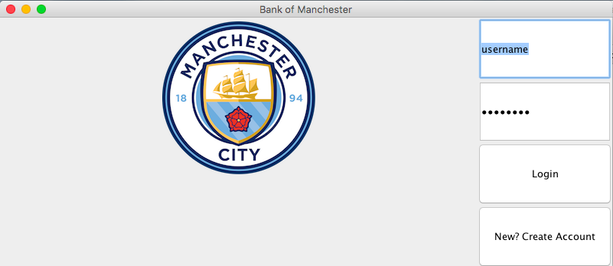









**Word Count:** 169